- Program ID : VA003MA1

- Display Layout
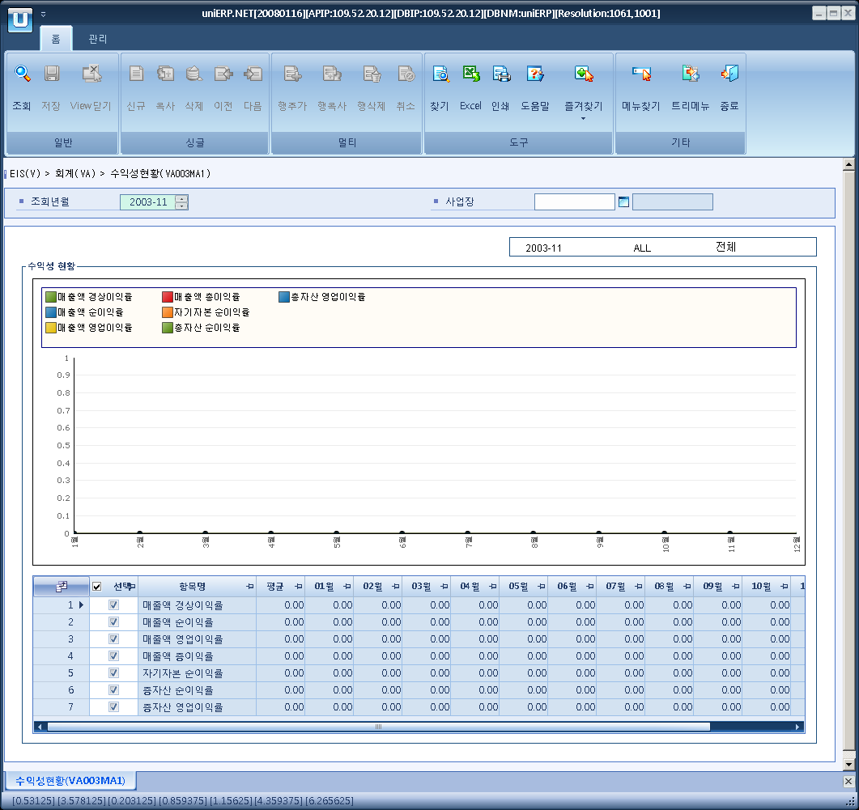

- Event flow
- Click Query button
- OnFncQuery -> DbQuery -> DataChange
- Display Unit combo change
- uniCombo1_ValueChanged -> DataChange

- SQL Statements
- profitable
SELECT a.minor_nm, a.avg_rate,
a.rate_1, a.rate_2, a.rate_3,
a.rate_4, a.rate_5, a.rate_6,
a.rate_7, a.rate_8, a.rate_9,
a.rate_10, a.rate_11, a.rate_12
FROM (SELECT b.minor_nm,
CASE ISNULL(sum(a.denominator_amt), 0)
WHEN 0 THEN 0
ELSE ISNULL(sum(a.numerator_amt), 0) / sum(a.denominator_amt) * 100
END avg_rate,
SUM(CASE WHEN a.order_seq = 1 THEN a.profit_rate END) rate_1,
SUM(CASE WHEN a.order_seq = 2 THEN a.profit_rate END) rate_2,
SUM(CASE WHEN a.order_seq = 3 THEN a.profit_rate END) rate_3,
SUM(CASE WHEN a.order_seq = 4 THEN a.profit_rate END) rate_4,
SUM(CASE WHEN a.order_seq = 5 THEN a.profit_rate END) rate_5 ,
SUM(CASE WHEN a.order_seq = 6 THEN a.profit_rate END) rate_6 ,
SUM(CASE WHEN a.order_seq = 7 THEN a.profit_rate END) rate_7,
SUM(CASE WHEN a.order_seq = 8 THEN a.profit_rate END) rate_8,
SUM(CASE WHEN a.order_seq = 9 THEN a.profit_rate END) rate_9,
SUM(CASE WHEN a.order_seq = 10 THEN a.profit_rate END) rate_10,
SUM(CASE WHEN a.order_seq = 11 THEN a.profit_rate END) rate_11,
SUM(CASE WHEN a.order_seq = 12 THEN a.profit_rate END) rate_12
FROM va0030t a
INNER JOIN b_minor b
ON a.profit_flag=b.minor_cd
AND b.major_cd = 'v0003'
WHERE a.sp_id = @strSpid
GROUP BY b.minor_nm) a

